**Lab 5: Create a Custom Virtual Private Cloud**

**Objective:**

Learn to build a Custom VPC, set up subnets, and configure security in AWS.

**Architectural Diagram:**

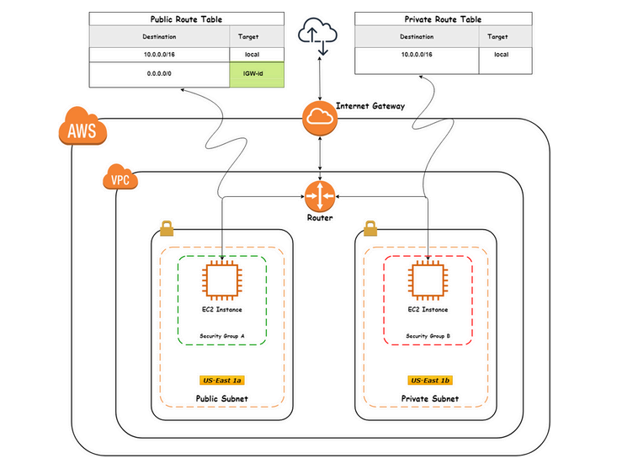

**Steps:**

* Set up a Custom VPC with public and private subnets.
* Configure Internet Gateway and NAT Gateway for internet access.
* Launch instances in both subnets and connect via Bastion Host.

**Step-by-Step Instructions:**

1. Create The VPC:

* Name Tag > Ipv4 Cidr block > Click Create Vpc.

1. Create An Internet Gateway:

* Click Create Internet Gateway.
* Attach IGW to respective VPC.

1. Create Subnets:

* Create Public Subnet > Choose availability zone > Assign Cidr Block.
* Create Private Subnet > Choose availability zone > Assign Cidr Block.

1. Configure Route tables:

* If you created the Vpc means Route table created manually

Is called as Main Route table.

1. Enable Auto-Assign Public Ip for Public subnets.

* Select the PublicSubnet.
* Click Actions > Modify auto-assign IP settings.
* 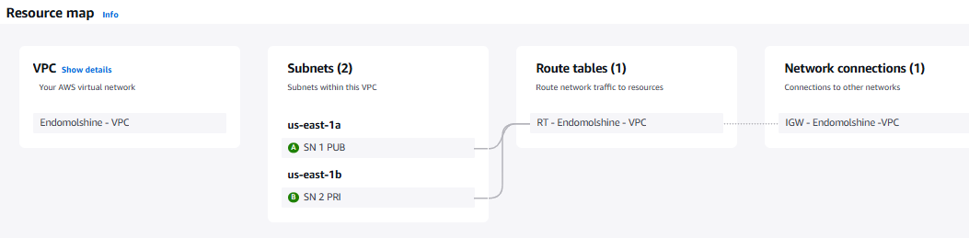Enable Auto-assign public IPv4 address.

1. Launch Ec2 Instance Both Subnets Connect Via Bastion Host.

* Connect the Public instances via Bastion Host using Pem key.
* Connect the Private instances using the following Command to Jump public instances to private instances.

1. Commands:

* Sudo vi test.pem > ssh -i test.pem

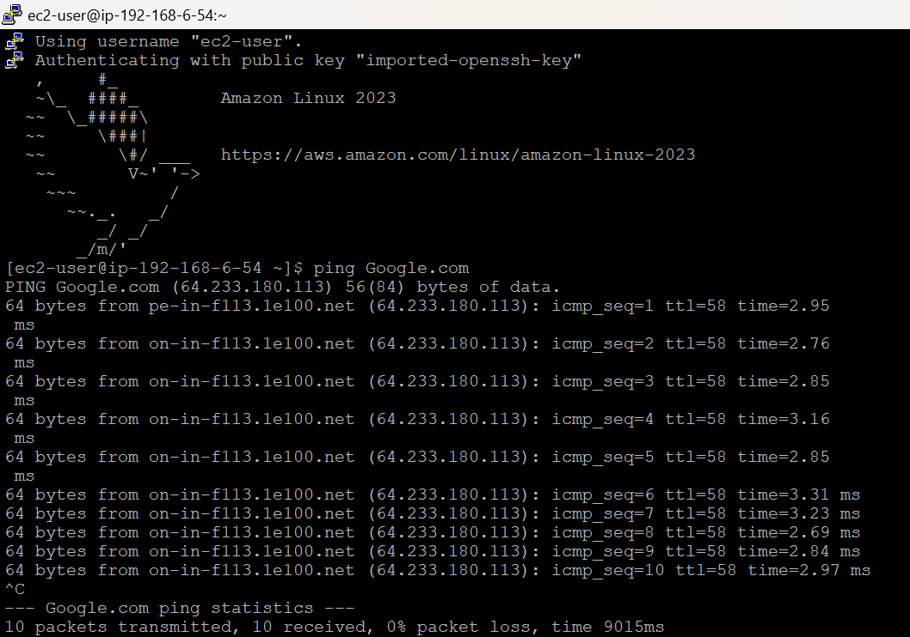Public Bastion Host:

Private Bastion Host:

